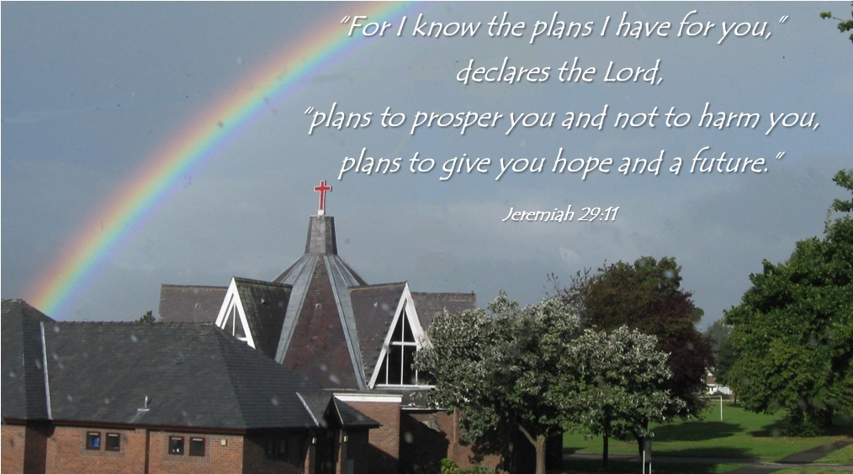**St John’s Church, Wrexham**

Annual Vestry Meeting

12 February 2025

Agenda

* + 1. **Welcome and opening Prayers.**
    2. **Attendance and Apologies.**
    3. **Confirmation of Minutes of AVM 3rd March 2024**
    4. **Receive the Annual Report**
    5. **Elections:** The AVM is responsible for the election of the following:

**5.1 The People’s Warden:**

The Vicar’s Warden is appointed by the Vicar.

**5.2 Members of the Church Committee:**

Nominations can be received and agreed, or it can be proposed that everyone on the Electoral Roll are considered members of the committee.

**5.3 Election of a member of the Mission Area Conference**

**5.4 Election of a representative to serve on the Diocesan Conference**

**5.5 Appointment of Sidespersons:**

* + 1. **Presentation of the Accounts**

Thanks to Sue Williams for her work.

**6.1 Church Accounts.**

**7. Any Other Business previously notified to the Secretary**

**The Church Committee will now co-opt a Secretary & Treasurer and formally accept the report and accounts.**

**St John's Church Annual Vestry Meeting  
Sunday 3 March 2024 During the 4.00 p.m. service in Church.**

Everyone is welcome to attend and Electoral Roll members are eligible to vote and stand for office.

1. Welcome and opening prayer – Sarah opened the meeting in prayer.
2. Apologies for absence – None
3. Minutes of 2023 AGM – Were agreed as being a correct record of the meeting.
4. 2023 Annual Report and Accounts –

* Sarah reflected that she felt encouraged that she was able to write that our attendance figures show a steady attendance, numbers haven’t increased but we are all pleased that numbers haven’t decreased.
* We sent out invitation to Candlemass and we had a baptism family attend, which was encouraging.
* Sarah remains concerned about the lack of corporate prayer. We were meeting once a month before the service but this fallen by the wayside.
* Toilets – a plumber is going to come and install a flush on the urinals.
* This will be Sarah’s last annual meeting, Elin will be moving to another church.
* There is a meeting planned for 7/4 during the Sunday service, with Jonathan and the Arch Deacon will be attending to discuss the way forward. Sarah requested that we pray for wise decisions to be made and that there are enough people to cover the practicalities.
* Reviewing the Annual Financial return – Income is around £26,000, £13,000 came from the hall, the other money came from giving, legacies and fees. The hall is subsidising the church. The parish share is £21,000, church is unlikely to finish the year with any funds. Steve Errington has been working hard to resolve outstanding issues with the church, this includes: missing slates on the roof, repairing the cross over the front door, the flat roof has been repaired and the faulty sky lights have been repaired and screwed shut. There is a boiler service this week, we are going to see if the Berco boiler can be repaired, may mean that we don’t have a boiler going forward as a replacement boiler will be about £1,500.

1. Diocesan Conference Report – The 2022 Diocesan Conference took place via Zoom on Saturday 8th October. The theme was Growing Faith, Bringing Hope, Demonstrating Love. Keynotes speakers were Cannon Richard Peers and Dr Gemma Simmonds. Pauline Wright is John’s representative on the Diocesan Conference, Pauline said it is generally very interesting and inspirational at times, she has agreed to continue in the role.
2. Election of Officers
3. People's Warden – No one appointed.
4. Vicar's Warden (appointed by the Vicar)
5. Church Council members – Pauline Wright, David Walker, Cathy Smith and Steve Errington.
6. Lay Representatives to Mission Area Conference – No one was elected.
   1. Appointment of Independent Examiner – No longer required.
   2. Other Business – David Walker expressed the churches grateful thanks for all of Sarah’s hard work and commitment to the church, she will be greatly missed. Steve’s faithful contribution and hard work for St John’s was also acknowledged.
   3. Closing Prayer – Sarah Closed in prayer.

**Annual Report 2024**

Throughout the year, worship at St John’s has been maintained on Sundays at 4.00pm and Wednesdays at 10.00am. The Sunday service has continued to take the form of a café-style service, called ‘Service Station’ with refreshments served as people arrive and seating around tables. The biblical material is presented interactively, and all are welcome to share in the prayers. Music is provided digitally and is generally contemporary in nature. Holy Communion is usually celebrated on the 4th Sunday of the month. On Wednesday, the 1984 ‘green’ prayer book continues to be used, and the service is always Holy Communion. Average attendance on Sundays has been around eight adults with seven for the Wednesday service meaning that the average number of active worshippers remains around 15. It has been good to welcome new people during the year to both services.

Sarah Errington, who had been vicar at St John’s since 2010, left for the Diocese of Salisbury in May. The church hosted a Mission Area farewell service in May and a further service in for just the church family later in the month. Since then, worship has been led by Jonathan Smith, Mission Area Leader, Dylan Parry Jones, Vicar of All Saints and Holy Trinity and Neil Barlow, reader in the Mission Area supported by some retired clerics.

The church has hosted some events displaced from St Mark’s Church due to refurbishment along with meetings of Christians Together in Wrexham, the Mission Area Conference and a Mission Area Healing service. At Christmas, St Anne’s Roman Catholic Church used the building for services due their building having asbestos removed.

A number of meetings were convened by the Archdeacon to explore how St John’s might move forward in the future and what gifts might be expected of a new vicar. Further work was undertaken by the Church Committee. A subsequent open church meeting has brought all of these thoughts together and a profile for the job is being prepared.

The Hall has seen active use by outside groups throughout the year managed by Shaun Davies. Some remedial work has been undertaken as necessary. There is concern about the failure of the soakaways in both the hall and church carparks. Following investigation, it would appear the problem lies on the adjoining playing field and this matter will be taken up with the local council.

**Mission Area Conference**

During 2024 the MAC has conducted the following business:

* The appointment of a part time MA Administrator
* The formal employment of Mr Shaun Davies as Halls Manager
* Considered the various issues in changing from a charity to a CIO Charitable Incorporated Organisation.
* Discussed the future shape of the Mission Area and acted as required in the closure of St James
* Overseen the property held by the MA, keeping a watching brief on significant projects at St Mark’s, St Margaret’s and St Giles’
* Overseen the MA budget and ensure the payment of the parish share.
* Checked on Safeguarding in the MA
* Promoted MA events including the Easter Vigil and Healing service
* Dealt with faculties as required.

**Diocesan Conference**

The 2024 Diocesan Conference, held in Llanfyllin High School, focused on Growing Faith as one of the key diocesan objectives. The Keynote speaker was Mones Farah from St David’s Diocese. With family living in parts of the middle east and wide range of experiences of Christian and Church life, this was an interesting and inspiring address. There were also short video presentations from a range of churches around the diocese demonstrating what can be achieved to grow faith with limited resources. We also heard about the Energy Footprint Tool which helps churches reduce their bills and carbon footprint.

**Christians Together in Wrexham**

The following events and activities took place in 2024

* 4 Quarterly meetings providing a voice for the various shared projects and chaplaincies in Wrexham and an opportunity for churches to learn from each other.
* 3 United services: for the Week of Prayer for Christian Unity at the Methodist Church, for Christian Aid Week in Capel y Groes and at the end of November in Bethel Church, Garden Village.
* Good Friday walk of Witness
* Consideration of a new website
* Planning of a visit of Oddments Theatre Company
* A seat on the Town Board
* Provision of a City Prayer Guide and App

**Financial Review**

Total receipts on ordinary unrestricted funds were £33,166 and are detailed in the Annual Financial Return.

Total payments in the year from unrestricted funds were £39,963. The largest item of expenditure was the Parish Share £15,088. This is paid to Wrexham Mission Area and then forwarded to the St Asaph Diocesan Board of Finance to enable it to provide the parish with clergy and support services.

The net result for the year for unrestricted funds was an excess of payments over receipts of £6,797.

**Reserves Policy**

It is Church Council policy to maintain a balance on unrestricted funds (if possible), which equates to at least three months' unrestricted payments, to cover emergency situations that may arise from time to time. At the end of 2024, the actual reserves totalled £3,788 which equates to approximately £3,412 less than our estimated three-monthly expenditure.