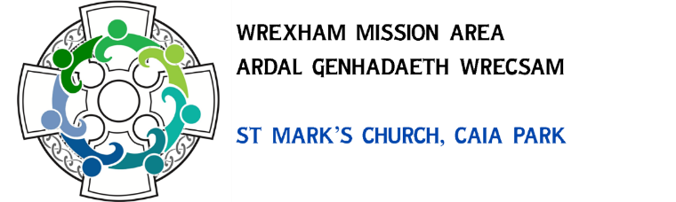
Wrexham Mission Area
Registered Charity 1199546
Annual Report 2024
Our Churches
Worship and associated activities were maintained across our six churches together with ongoing support for St Mary’s Bersham throughout the year under review. St Giles’ has continued to welcome good numbers to services of differing styles along with other events and embarked on a significant project to replace the chancel roof and repair associated stonework. Work also started to refurbish and enhance St Mark’s building which has necessitated all its activities being relocated. St John’s remains a small in numbers but continued to provide services of worship on Sundays and Wednesdays with help from the ministry team following the departure of their vicar in May. Congregations remain strong at All Saints and St Margaret’s with Holy Trinity also welcoming new people.
It was with great sadness that the final service was held in St James’ Church on Sunday 21st April. This closure was painful for all involved and many questions raised by the process remain unanswered. The MA has continued to maintain the building pending the completion of the faculty requirements before it can be handed over to the Representative Body of the Church in Wales.
Shared Mission Area Events
An Easter vigil for the Mission Area was held at St James’ when the Paschal Candles of all the church were first lit. This was an opportunity for people from across the Mission Area to support St James’ Church as it prepared for closure. An open invitation was made to an early morning Ascension Day service on the tower of St Giles’ followed by a cooked breakfast. Bishop Gregory presided at a confirmation service at St Margaret’s in the autumn with candidates from All Saints, St Margaret’s and the Alyn Mission Area. There were also shared services of valediction and welcome for departing and arriving clergy.
Mission Area Conference
The MAC is both the PCC and the Board of Trustees for the Mission Area. It met on five occasions during 2024. Consideration was given to the viability of all our churches and the number of stipendiary clergy which could be employed under the present Diocesan share formula. Later in the year, there was discussion of the future of St John’s and a potential pairing with St Mark’s was considered a possibility to be shared with the diocesan leadership.
With diocesan encouragement, thought was also given to changing the charitable status of the Mission Area from a Registered Charity to a Charitable Incorporated Organisation (CIO) It was agreed to make this change although work on this was still ongoing at the end of the year.
Building projects continued to be overseen by the MAC with the possibility of a Property
Sub Committee remaining unrealised. The MAC also has the responsibility to sign off faculty applications for the Mission Area Churches and discuss significant building projects, notably at St Mark’s and Giles’.
Personnel
At the beginning of the year, the Mission Area continued to support four stipendiary priests. Sarah Errington left to take up a post in the diocese of Sailsbury leaving a vacancy at St John’s. In August, Jason Bray, vicar of St Giles’ departed to become dean of Llandaff Cathedral in Cardiff and the following month, Petra Goodband was licensed to her role as associate priest at St Giles’. Her post, funded by the diocese through the Church Growth Fund was intended to be the start of the ‘Hub’ church development at St Giles’ with a focus on music, but by default, Petra took over Jason’s duties until a replacement was appointed. We were grateful to Brian Stickles and Nick Roe for serving as MA wardens. We welcomed Sarah Namirembe on St Padarn’s placement with St Margaret’s and St Mark’s and Elin Douglas Jones continued her placement at All Saint’s and Holy Trinity. Alex Cottrell began an apprentice role in the same churches. It was also good to have Karen Reynolds and Shaun Davies on board as Administrator and Hall Manager respectively
Church Army Centre of Mission & Hope Street
The Ministry Team works closely with these other expressions of Anglican ministry in Wrexham. The Mission Area Leader line manages the Centre of Mission which runs the Tin Can Youth Centre providing a Christian witness to many young people with no church background. In turn, the Centre of Mission works collaboratively with Hope Street on projects such as the Coleg Cambria Chaplaincy and Bridge the Gap football ministry. Links are also maintained with other churches through Christians Together in Wrexham along with prison and school’s ministries. The Mission Area remains a member of Together Creating Communities. (TCC)
Finance
We have managed to pay the Mission Area share to the diocese in respect of our clergy and support services for 2024, but many of our churches are struggling to maintain these obligations alongside the maintenance of their buildings. We have negotiated a drop in our clergy figure for 2025 from 4 to 3 ½ which will reduce our overall obligation to the diocese.
I am very grateful to Carol Jones, Sue Williams and Karen Reynolds all of whom worked hard with the treasurers and the auditors to ensure the accounts for 2023 were posted in time on the Charity Commission Website.
Jonathan Smith, Mission Area Leader
June 2025

